

Year 11 Specialist Mathematics
Semester 2, October 2021
Test 6: Complex Numbers and Number Proofs
Calculator Free Section
Weighting: 6%
[Australian Curriculum Reference Numbers: 2.3.1 - 2.3.16]
Total Marks = $\frac{}{48}$
Total Time: 25min Marks = $\frac{}{26}$
Student Name:
Teacher: ___________________________________

INSTRUCTIONS TO STUDENTS:
- You are not allowed a calculator or any notes.
- A formula booklet will be provided.

You are required to attempt ALL questions.
Write answers in the spaces provided beneath each question.
Marks are shown with the questions.
Show all working clearly, in sufficient detail to allow your answers to be checked readily and for marks to be answered for reasoning. Incorrect answers given without supporting reasoning cannot be allocated any marks. For any question or part question worth more than two marks, valid working or justification is required to receive full marks.

- Given that $z=2-i$ and $w=2i+5$, determine the following:
(express your answers in the form $a+bi$, where $a$ and$b$ are real)
  - $\overline{w}$

  - $w\overline{z}$

  - $Re\left(w\right)+Im\left(\overline{z}\right)$

  - $\frac{w}{zi}$

  - $|w\overline{z}-w|$
[1,2,1,3,2 = 9 marks]

  - Solve $z^{2}+3z+3=0$ over the complex plane.

  - 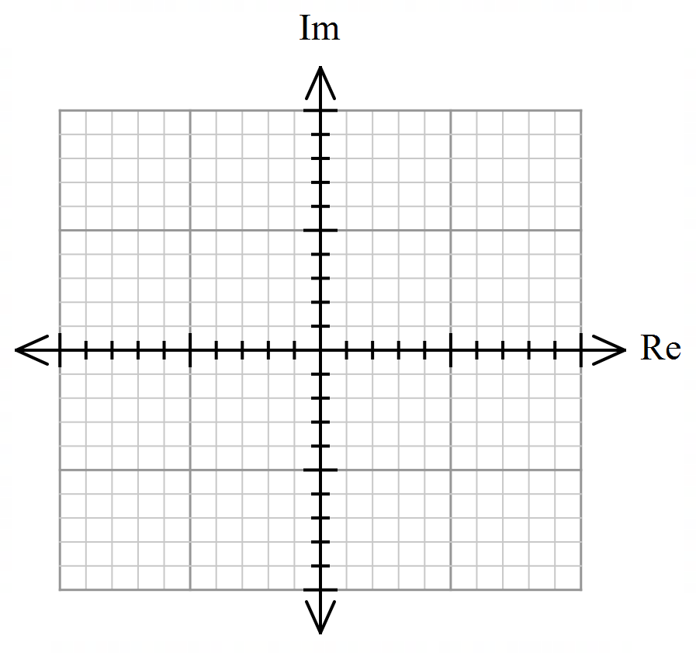Sketch the solutions to $z^{2}+3z+3=0$ on an argand diagram, labelling them $z_{1} and z_{2}$

  - What geometric property do the complex roots of quadratic equations with real coefficients display?
[3,2,1 = 6 marks]

- Sketch the complex numbers as vectors on the Argand Diagram below.
$$z_{1}=2+i, { z}_{2}=\frac{3}{-i}, { z}_{3}=i^{7}z_{1}, { z}_{4}=\overline{z_{2}}, { z}_{5}=\frac{1}{9}z_{1}z_{2}z_{3}z_{4}$$

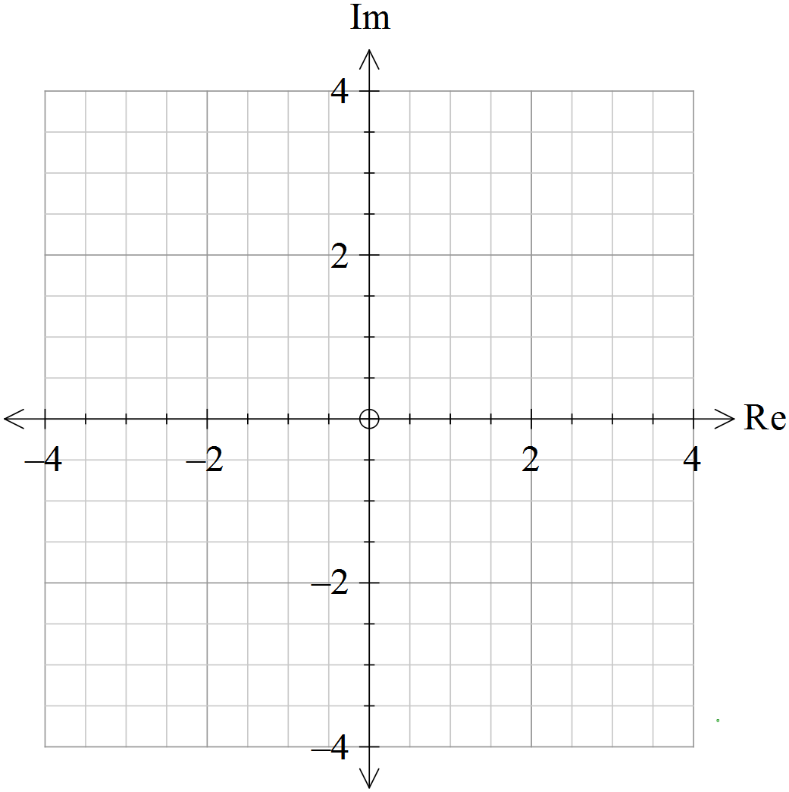
[8 marks]

- Convert the decimal $2.3\overline{7}$ into the form $\frac{a}{b}, a,b∈ Z^{+}$ where $a and b$ have no common factors.
[3 marks]

*** End of Test ***

***Extra space for working out***




Year 11 Specialist Mathematics
Semester 2, October 2021
Test 6: Complex Numbers and Number Proofs
Calculator Allowed Section
Weighting: 6%
[Australian Curriculum Reference Numbers: 2.3.1 - 2.3.16]
Total Time: 25min Total Marks = $\frac{}{22}$
Student Name:
Teacher: ___________________________________

INSTRUCTIONS TO STUDENTS:
- You are allowed a calculator, but you are not allowed any notes.
- A formula booklet will be provided.

You are required to attempt ALL questions.
Write answers in the spaces provided beneath each question.
Marks are shown with the questions.
Show all working clearly, in sufficient detail to allow your answers to be checked readily and for marks to be answered for reasoning. Incorrect answers given without supporting reasoning cannot be allocated any marks. For any question or part question worth more than two marks, valid working or justification is required to receive full marks.

- Use proof by exhaustion to prove that:
$$The cube of any integer is always either \\ a multiple of 9, or 1 away from being a multiple of 9$$
Hint: Consider integers as multiples of 3.
[ 8 Marks]

- Prove that any complex number multiplied by its conjugate will always give a real number.
[3 marks]

- For the Argand Diagrams below:
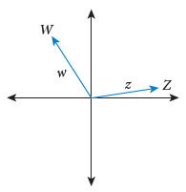  - Sketch $\overline{z}$ |   - Sketch $iz$
  - Sketch $w-z$ | 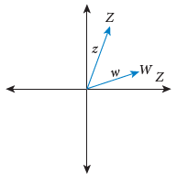  - Sketch $2i^{26}w$
[4 marks]

- Prove that:
$$\frac{1}{1×2}+\frac{1}{2×3}+\frac{1}{3×4}+…+\frac{1}{n\left(n+1\right)}=\frac{n}{n+1}, for all positive integers n$$

[7 Marks]
** End of Test **
***Extra space for working out***

